# Problem Statement

“RTD has seen a steady decline in ridership on both its trains and buses over the last few years, dropping from more than 103 million boardings in 2015 to fewer than 98 million last year.*” Additionally, the light rail has faced severe delays and cancellation in 2019, including those caused by outages, operator shortages, weather, and maintenance issues. Of the trains surveyed by RTD from December 2018 through November 2019, 83% of the station’s departures occurred after they were scheduled. In fact, CBS4 reports that in November 2019, RTD began surveying the public to see if service cuts or delays and cancellations are preferred in the wake of the driver shortage.

With decreased ridership, reliability, and workforce, RTD faces a triple-pronged problem that will continue to escalate moving into 2020. RTD is considering new pricing program and has multiple line expansion operations underway. However, one key item to track and improve across all these efforts is consistent and timely adherence to train schedules.

Purpose of Analysis and Model

To help RTD in this effort in providing riders with consistent reliability, a model will be built to predict trains’ departures from each station on its scheduled line. Knowing a station’s scheduled departure, the minutes delayed until predicted departure and ultimately the forecasted departure time will allow prospective riders to plan accordingly. With wait times for a single line ranging from 15 minutes to over 30 minutes, it’s critical that riders board their expected train.

A model that can predict any future train’s expected departure has both B2C and B2B opportunities. The obvious usage of such a model can be seen with a direct to consumer model, wherein RTD can provide riders with the output of such a model. Currently, RTD has 2 independent offerings that seek to help riders plan trips using their services.

1. Rider Alerts (<https://www.rtd-denver.com/app/alerts>) on RTD’s public domain provides a listing of service lines affected by scheduled or known delays/cancellations.
2. Trip Planner (<https://www.rtd-denver.com/app/plan>) also on RTD’s public domain provides an interactive planning interface allowing visitors to select a starting and ending destinations as well as departure or arrival date and time.

Both of these services fill a large gap for RTD’s riders. However, there is room for improvement. Currently the Trip Planner does not consider detours, cancellations, and other special circumstances and encourages riders to view the Rider Alerts for those delays/cancellations that were scheduled/known. Instead, the Trip Planner considers scheduled services with adjustments based on real time vehicle location information.

Thus, a model that considers scheduled service, special circumstances/events, and leverages historic data to forecast service in the future could be used to improve current trip planning features offered by RTD. In a continued effort to increase ridership, the model can also be provided or licensed to local vendors who’s websites provide directions via RTD. With a model that can predict future train service, patrons of other commercial establishments can better plan their logistics more appropriately using RTD.

Data Landscape and Overview

To begin the construction of this model, light rail data spanning December 2018 through November 2019 provided by RTD will be used. This data details service lines’ arrival, departure, and scheduled departure at each station. RTD currently considers departure time compared to scheduled departure time when evaluating for train delays.

There are some known gaps in the provided RTD data that will impact the comprehensiveness of the model constructed. These gaps are listed below.

* RTD leverages Automated Passenger Counters (APCs) to collect the provided data. Approximately 30 percent of RTD's light rail vehicles have APCs installed. All of the commuter rail vehicles have APCs installed; however, not all APCs report every day for various reasons.
* Snow days are determined by examining the arrival times of buses at Union Station and Civic Center station. If more than 30% of the buses are more than 5 minutes late on that day, then the date is eliminated from the data set.
* Since RTD evaluates performance in regards to departure time, most end terminal stops do not feature a performance evaluation.

In addition to the provided RTD data, special occurrences and activity must be considered to further improve the Trip Planner offerings. The below areas are being considered as additional inputs into the model:

* Local hourly and daily weather from the National Centers for Environmental Information for Adam, Arapahoe, Denver and Jefferson counties
* Start game times of regular season games hosted by the Broncos, Nuggets, Rockies, and Avalanche from <https://www.sports-reference.com/>.
  + Preseason and postseason games will be considered where applicable
  + End game times are not currently available and will not be considered

Approach and Methodology

To identify which input variables should be considered for the resulting model, the correlation between independent input variables and departure delays will be measured. Various regression models will be used to determine the best fit and correlation coefficient for each variable. Once a selection of input variables have been made, a predictive machine learning model will be constructed, trained, and tested in its ability to predict the continuous output variable of number of minutes delayed in future train departures.

Deliverables

The final Deliverable will be a jupyter notebook consisting of instructional walkthrough and corresponding code to be executed at each step in the analysis and model creation, from data ingestion to model output and assessment. Along with the Jupyter Notebook, a powerpoint deck will be created that details the problem being solved, analysis, and recommended solution.

# Data Wrangling Effort

Library and Initial File Imports

For data import retrieval and manipulation, the following libraries were imported:pandas, numpy, datetime, and timezone. For initial discovery through visualization, the following libraries were imported: matplotlib.pyplot and seaborn.

Two files were initial imported: 1) station departure records of light rail trains and 2) station identifier translations. Each file was imported as a csv with a ‘;’ (semicolon) delimiter.

Stop Identifier Cleaning

To leverage stop names used by the public, the train data was merged with the stop name lookup file to bring the stop name into the station departure data. Some STOP IDs do not exist in the lookup file and thus do not have stop names. For these stations, the MAIN_CROSS_STREET field will be substituted for the STOPNAME.

To complete these translations, a dataframe was created of relevant and unique STOP IDs and their corresponding STOPNAMEs. This file was then merged into the train data. A separate list of STOP IDs were created that are only available in the train data, by making use of the indicator parameter on the merge method. These stops’’ MAIN_CROSS_STREET value were used to replace the STOPNAME in place in the train data.

Removal of Unnecessary Fields

The following fields were removed as they only feature nulls or a consistent value across the entire dataset: ‘ON_DETOUR', 'SL_COUNT', 'SM_COUNT', 'AVL_COUNT',' SL_AVAILABLE', 'SM_AVAILABLE', 'AVL_AVAILABLE', 'APC_AVAILABLE'.

Creating Consistent Formatting in Datetime Fields

There are 3 native datetime fields in the train data: 'TIME_ACTUAL_ARRIVE', 'TIME ACTUAL DEPART', ‘TIME_SCHEDULED’. The fields represent when the train actually arrived at the recorded station, when it actually departed, and when it was supposed to depart, respectively. Please note that expected arrival is not native in the data.

TIME_ACTUAL_ARRIVE and 'TIME ACTUAL DEPART were set to December 31, 1899 as defaulted by Oracle. Their timestamps were appropriately set. TIME_SCHEDULED carried both an accurate date and time of the scheduled departure. Thus, after transforming all fields to datetime objects, the date from TIME SCHEDULED was merged with the time fields of TIME_ACTUAL_ARRIVE and TIME ACTUAL DEPART to create accurate datetime fields, ARRIVAL and DEPARTURE, respectively.

However, some train arrivals and departures strattle midnight, meaning their ARRIVAL, DEPARTURE, and TIME_SCHEDULED may occur on different days. Thus, a field was created for both ARRIVAL and DEPARTURE, indicating if there was a 12 hour (noted as 43200 seconds) difference between the respective time field and TIME_SCHEDULED. The DEPARTURE and ARRIVAL day stamps of these records were then adjusted accordingly.

Additionally, the field TIME_TO_SCH_DEPART was added that creates a range from ARRIVAL to TIME_SCHEDULED (departure) in seconds to illustrate trains that arrive after they were supposed to have already departed.

Fill Empty County Field for Weather Merge

Hourly weather by county can be obtained to complement train data. However, some stations have NaN COUNTY information and ‘Douglas’ county is not available from <https://www.ncdc.noaa.gov/cdo-web/>.

Sky Ridge Station, Lone Tree City Center Station, and Ridgegate Parkway Station are in Douglas County but close to the Arapahoe County edge. These stations’ COUNTY value was replaced with ‘Arapahoe’.

A unique dataframe of STOPNAME with NaN corresponding COUNTY values was created and saved to a local csv file. These stations were then researched to find their corresponding counties and read back in as a new dataframe. The value of the merged County field was then used to update the LOOKUP_COUNTY field and a final list of 4 distinct LOOKUP_COUNTY values was confirmed: 'Denver', 'Adams', 'Arapahoe', 'Jefferson'.

Rockies Data Cleaning

The 2019 Rockies game results was obtained from sports-reference.com and saved to an excel file. However, the data did not include start times. For start times, the original 2019 schedule published by the Denver Post was used. Both files were read in as data frames and datetime objects transformed accordingly.

There were 4 Date values in the games file that were set to NaN after transforming the field to a datetime objects. These 4 values correspond to double header games played on ‘2019-07-15’ and ‘2019-07-24’. These dates were set manually after being discovered and researched.

Away games were removed from both files and the All-Star Break record was removed from the times file by dropping the rows corresponding to the applicable indexes. Indexes were then reset.

For additional validation for future merging of times and games, the unique list of opponent abbreviation (‘Opp’) ,i.e. LAD, from the games file was merged with the corresponding opponent definition (‘Opponent’), i.e. Los Angeles Dodgers, from the times file. A dictionary was created with these opponent fields and used to map to a new field in the times file labeled as Opp_Cd.

Finally, the times and games files were merged into a single file using Date and Opp from the games file with Sch_Date (renamed from Date) and Opp_Cd from the times file. Further validation was performed and adjustments made to correct for the following anomalies:

* Game on May 8th was canceled
* Cancelled game was replaced with game on August 26th starting at 3:10pm
* Double-header on July 15th started at 12:10pm.

Broncos Data Cleaning

Broncos data for the 2018 and 2019 seasons were obtained from sports-reference.com as excel files. The files include both date and time of kickoff for each game played by the Broncos. They were both read in as dataframes, combined, and away games and bye weeks removed.

Nuggets Data Cleaning

Nuggets data for the 2018-2019 and 2019-2020 seasons were obtained from sports-reference.com as excel files. The files include both date and start time of each game played by the Nuggets. They were both read in as dataframes, combined, and away games removed.

Avalanche Data Cleaning

Avalanche data for the 2018-2019 and 2019-2020 seasons were obtained from Altitude TV Network as excel files. The files include both date and start time of each game played by the Avalanche. They were both read in as dataframes, combined, and away games removed.

Setting Game Times to 24-Hour Clock

The train dataframe features times based on a 24-hour clock. For future merging, sport game start times had to be converted to the same format.

The Rockies Time field was converted to a datetime.time value after manually fixing the value set as 1pm as it was inconsistent with other formats.

The Broncos timestamps were set according to US/Eastern. After merging the date with the time as a datetime object, the timezone library was used to make the datetime aware of its time zone and subsequently convert to US/Mountain time.

Lastly, the Nuggets and Avalanche games were both set to datetime.time objects.

Merging Games into Train Data

For each day in the train data, there can only be up to one game played by the Broncos, Nuggets, and Avalanche. Thus, each one was merged into the train data, incrementally, by joining on the respective Date columns.

However, there was a single day in which the Rockies played 2 games. Thus, 2 data elements were created to merge into the train data - time of first game and time of second game. To create these columns, the rockies data was grouped by Date and Opp and the first method was used to grab the first game on each day. The grouped dataframe was then merged once again to the original rockies dataframe grouped according to the last game played on each Date and Opp combination. Duplicative times across the first and second game times were set to blank spaces and then filled with NaN using a regex expression within a replace method. The day of the double header was then used to confirm the appropriate result. Finally, the consolidated rockies dataframe was then merged into the train data similar to the sport merges above.

Re-Calculating Dwell Time

DWELL TIME, while native in the original train data, was not always completed. Thus, WAIT TIME CALC was created by identifying the number of seconds between the actual departure and arrival of each train at each station.

However, this produced around ~260 rows in which the WAIT TIME CALC value was negative. These negative rows occurred when the date stamp from TIME SCHEDULED was used to replace the default date in TIME ACTUAL ARRIVAL to produce the ARRIVAL value. An inaccurately negative WAIT TIME CALC was produced when the actual arrival was shortly before midnight and the departure was immediately afterwards. To correct these mis-transformations, the day of the ARRIVAl values was reduced by 1 day for records in which the WAIT TIME CALC was less than -60 seconds. Please note that there is a single record in which the actual arrival of the train is 1 second after the departure. This record remains unaffected for now.

Merging in Revised Weather Data

Weather from NOAA was scarce and featured many data type conflicts across the county fields sourced. As a result, new weather data was sourced from Visual Crossing (visualcrossing.com) and spot checked for its accuracy. Unlike NOAA, Visual Crossing features hourly weather by city. As a result, a similar exercise was performed to ensure each record in the train data had a value for CITY.

Unfortunately, the native data featured 2 conflicting values for CITY for stations 'Red Rocks Community College Station' and 'Sheridan Station'. These records’ CITY field were set to ‘Lakewood’ and ‘Denver’, respectively. Additionally, missing CITY values had to be researched and set for certain STOPNAMEs.

The weather data from Visual Crossing was then merged into the train data using pandas’ merge_asof method, setting a timedelta tolerance of 1 day, meaning the difference between the recorded hourly weather and train DEPARTURE must not exceed a day. However, since weather was sourced by hour for the entire date range for each city, this tolerance is likely exhaustive.

The sourced weather data featured a column WEATHER TYPE that contained a listing of weather descriptions, such as Drizzle, Fog, Heavy Snow, etc. These listings were in no particular order and featured combinations of 22 unique descriptors. To create a cleaner version of this information, individual fields were added for each of the 22 descriptors, representing a flag for if a given record included that particular type of weather. For example, a row with a value of 1 in the ‘Heavy Snow’ column indicates that heavy snow was recorded at the time of the DEPARTURE.

Denoting End of Line Stations

While sorting trains departures by SORT_ORDER, the provided identifier for ordering stations in each line, the following key insights were gathered:

1. Not all of the provided lines’ stations are included in the dataset
2. Some lines’ final station are missing in the dataset
3. DEPARTURE_DELAY is highly skewed at the end of the line as timeliness is assessed by departure, which does not concern passengers as final stations.

To combat numbers 2 and 3 above, each line’s stations were explored both within the dataset and online. After completion of this research, an END_OF_LINE flag was added to the train data to be set to 1 if the record features a station at the end of the corresponding route/line. This process was done for each unique combination of BRANCH (line) and DIRECTION_NAME.

# Data Exploration

Follow successful ingestion of the RTD light rail data, several very evident insights came to light. First and foremost, 83% of trains are departing after their scheduled departure. Furthermore, while there is a substantial volume of early departures, the average departure is still occuring 1 minute and 42 seconds after its scheduled time. Below is a brief overview of some of the variables explored in pursuit of seeing what may cause these RTD delays. Sources of information and variables include RTD train data, local sporting events, and hourly weather.

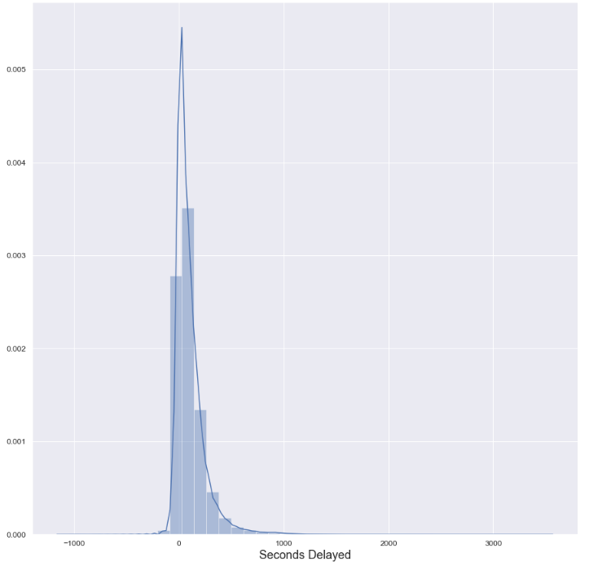

Train Line Breakdown

Evaluating departure delays by line (also known as branch internally to RTD), shows substantial variance in average delays. The best performing line (by departure delays) is line B, with an average delay of just under a minute. Alternatively, line F averages a delay of nearly 3x that of line B.

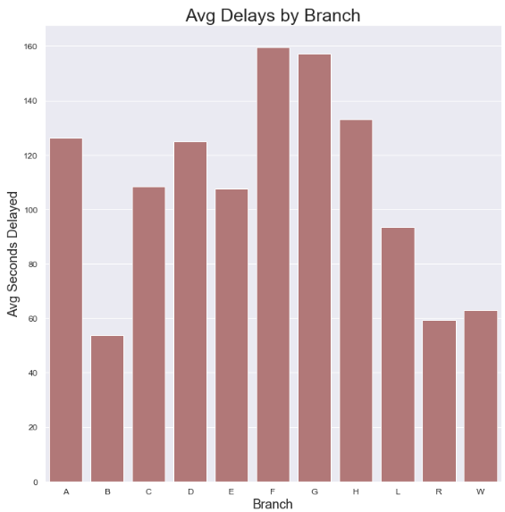

Exploration into Seasonality

While seasonal trends cannot be predicted with only a year’s worth of data, there are some spikes and climbs seen across December 2018 through November 2019. Both averaging delays using monthly snapshots and rolling averages (weekly, monthly, and quarterly) show a rather rapid climb between January to March and a spike in October 2019.

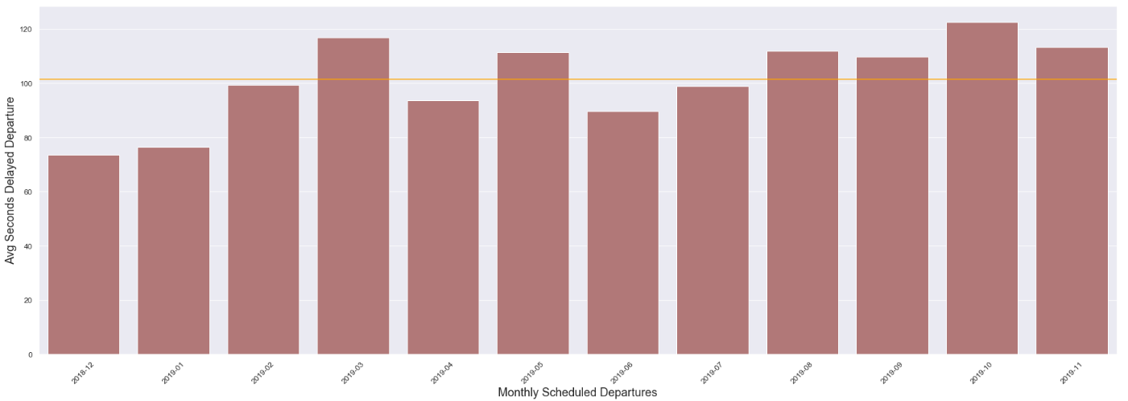

The initial climb may in fact coincide with weather, so there is reason to explore weather’s effect on delays further. The secondary spike in October however, may correlate to the driver shortage that became widely published in the final quarter of 2019, as it caused many train delays and cancellations.

Comparison of Direction, Time Period, and Station

In pursuit of additional variables for modeling consideration, several additional pieces of RTD data were compared. Interestingly, southbound trains tend to be more delayed while northbound trains perform better than the other 3 directions. Furthermore, this contrast is evident across all train lines with the exception of line L, wherein southbound trains outperform northbound trains.

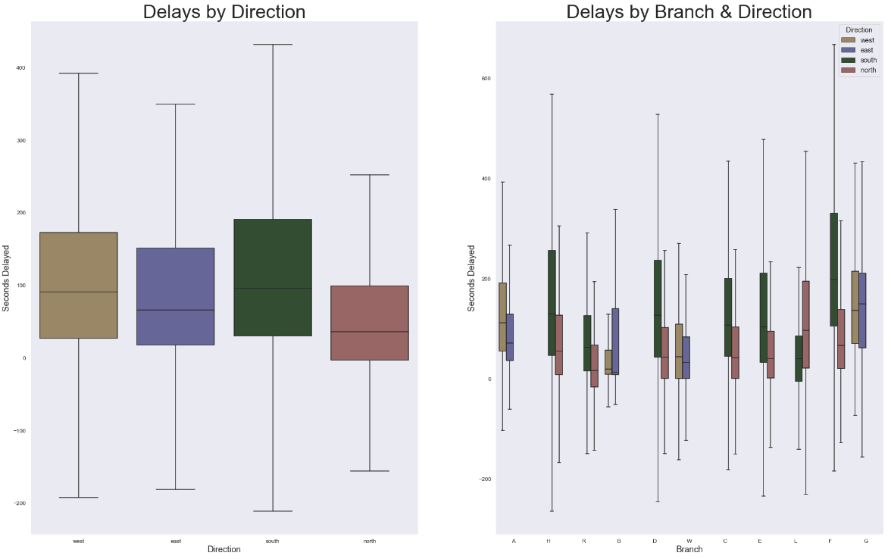

Comparing service (time) periods, i.e. morning rush hour and late evening, did not present any immediate findings but the service period classification should be considered for further analysis. In contrast, comparing departure delays across stations showed significant variance, presenting itself as possibly a significant predictive variable.

Impact from Prior Delays

As to be expected, delayed departures at prior stations will inevitably have an effect on current and future delays. However, what is interesting is that these delays do not continue in a flat, nor increasing manner. Instead, the linear correlation of prior delays decreases from 0.85 as one progresses further into a train’s previous departures. In other words, one may hypothesize that train operators are able to make up time as the train progresses through its schedule.

Local Sporting Events Influence

To better understand the effect local sporting events may have on train delays, the average delay on game days were compared to days without games. Specifically, the average delay of Rockies game days in Denver were compared to that of days during which the Rockies did not play in Denver. The same snapshot analysis was performed for the Avalanche, Nuggets, and Broncos.

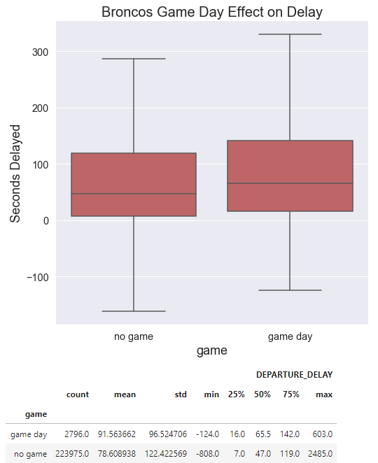

The average comparison did not show any immediate insight for the 4 teams, with the exception of the Broncos. Initial views showed a considerable increase in delays on Broncos game days. However, since most of these games are played on Sundays, comparing Broncos Sunday game days with Sundays during which the Broncos did not have a home game revealed the opposite - trains perform worse on Broncos Sunday game days.

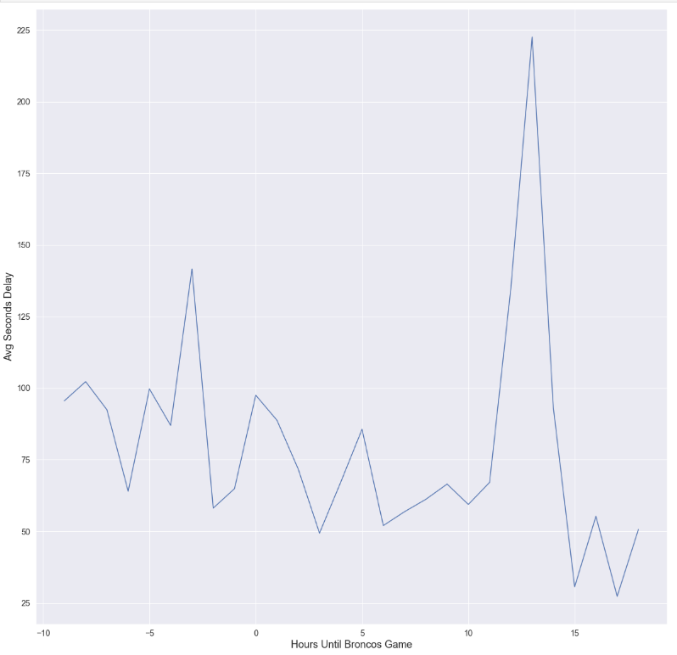

Furthermore, trending delays by their time-based proximity to Broncos kickoff time indicated 2 peaks occurring ~3 hours before kickoff ~13 hours after kickoff. The first spike could very well coincide with Broncos foot traffic and could be investigated further. However, the 2nd spike likely occurs well after the close of the game and could very well coincide with Monday morning rush hour after Sunday games.

Weather Exploration

Multiple weather variables are to be considered in their effect and predictive abilities in determining train delays. To start, linear correlations were obtained between departure delays and snow depth, precipitation, and wind speed. While all p-values are near 0, the correlations are very small: 0.1, (0.01), 0.01, respectively. Further exploration into weather conditions and the overlap of various measurements is recommended.

# Inferential Statistics Analysis

Similar to the prior exploratory data analysis phase, brief statistical analysis was conducted using the combined RTD light rail, local sporting event, and weather dataset. Beginning with the previously cleaned dataset, inferential statistics using bootstrap and Bayesian statistics were completed. These exercises are described below.

Difference of Delays between Good and Snowy Weather

Bootstrap inferential statistics was used to determine if one can be confident that the average delay on a snowy or icy day will be different than a “clear” day, specifically a day without snow or ice at the time of departure. To begin, delays were segmented by those that have a weather type corresponding to snow, ice, freezing rain, or hail and those that have none of these weather characteristics.

For each resulting series of delays, 50,000 series of the same length were generated by using a random selection (with replacement) from the empirical data. From each randomly generated series, a mean was captured. The 50,000 resulting “snow day” means were compared to those of the “clear days”. This produced a 95% confidence interval in the difference of means (in seconds) of [35.82728009, 39.10296803]. More importantly, this confidence interval does not near 0, indicating that “snow days” have statistically higher mean delays than non-snowy days.

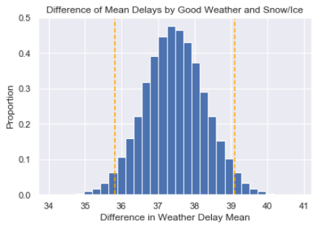

Isolate Southbound Train Performance

One of the more intriguing findings from the initial exploratory data analysis was that southbound trains seem to underperform compared to other directions.

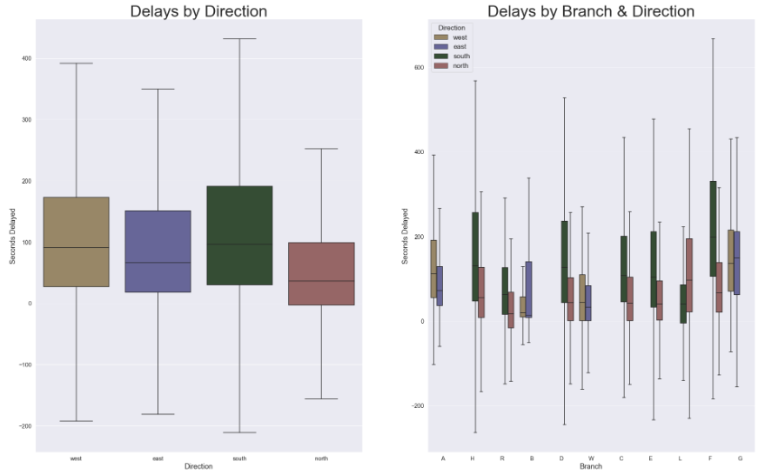

To test this hypothesis, permutation methodology was used to compare the average delays of southbound trains with non-southbound trains. Specifically, the delays of southbound trains were combined with delays of non-southbound trains and randomly sorted. Two new arrays were created to mirror the original lengths of the southbound and non-southbound delays. Lastly, the difference (called bootstrap replicates) of these 2 randomly generated arrays was captured.

Identifying the portion of the bootstrap replicates (using the above permutation method) that are greater than or equal to the difference found in the empirical data results in a 0% p-value. Such a low p-value indicates that the null hypothesis of southbound and non-southbound trains having the same average delay should be rejected.

Simulating Gamma Delay Distribution

Initial histogram view of delays suggested a right tail and possibly gamma-like distribution. Thus, a simulation was conducted using a gamma distribution and derived alpha and beta parameters was created to compare the simulated gamma output to the possibly gamma empirical distribution. While the fit is not perfect, it is close.

